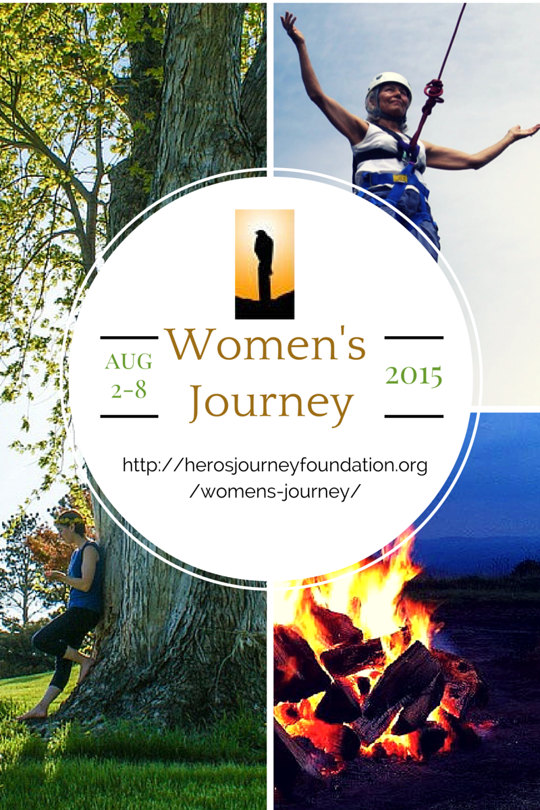

At certain times in our life, a journey filled with meaning and significance is undertaken in order to bring forth the essential nature of who we truly are.
The Hero's Journey for Women is one of these journeys. It is a life-altering and life-giving immersion into the ancient cycle of leaving home, experiencing adventure, joining with allies, challenging personal limitations, developing new insights, celebrating vitality, and then returning home to a new self.
It is an alchemical process - designed to bring forth, strengthen, and unite our deep feminine and masculine selves. This way of journeying re-awakens an essential place inside where every cell in your body says "yes" – and you realize that this is the way to be alive. You discover that it is necessary to give yourself over to “in the moment” adventure in order to experience a genuine transformation.
When we do this, Joseph Campbell said, "There is a track just waiting there for each of us, and once on it, doors will open that were not open before, and would not open for anyone else”.
The Hero’s Journey for Women provides each participant with an inspiring and supportive team of facilitators and support staff, enriching personal adventures rooted in beautiful, nurturing wilderness settings, and a revitalizing, life-giving process steeped in personal development.
You will be led by an international, culturally diverse staff. Our site is the Spruce Knob Mountain Center, surrounded by the Monongahela National Forest in the mountains of West Virginia, USA.
For any questions, or to explore if the Women’s Journey is right for you, please contact Anna Noack at anna@herosjourneyfoundation.org

