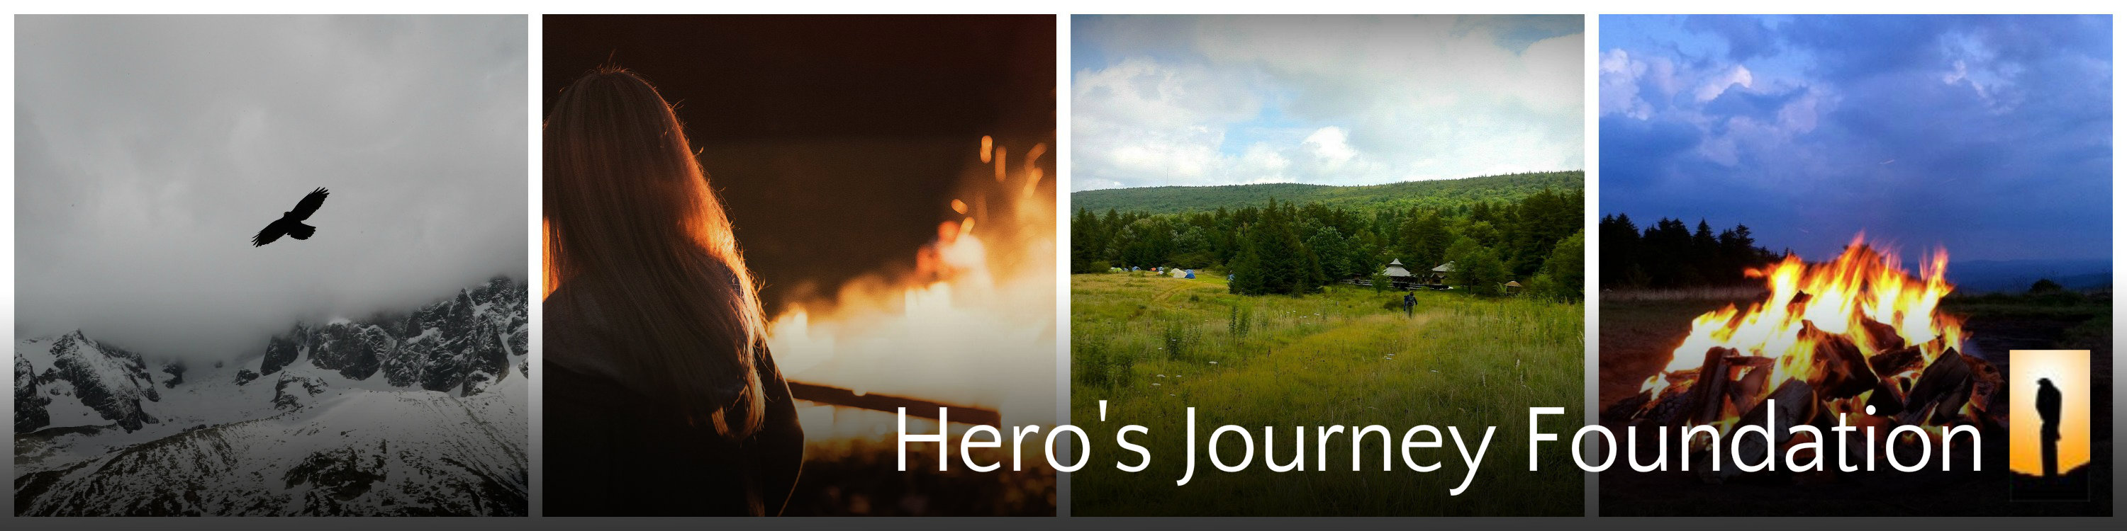

“Friend, hope for the truth while you are alive!
Jump into the experience while you are alive!
What you call ‘Salvation’
Belongs to the time before death.”
- Kabir
May 2015

Dear

You are now enrolled for our Women’s 2015 Hero’s Journey Intensive! We have received your deposit and/or payment; it is now time to open yourself to new possibilities and new ways of living, in preparation for your upcoming journey in August. The Women’s Hero’s Journey Intensive is inspired by the teachings of Joseph Campbell’s mythic works. You are giving yourself a great opportunity for a life altering ‘Passage’ of sorts. It may be unlike anything you’ve ever experienced.

We follow a basic mythic paradigm that has existed throughout every culture and tradition since the beginning of time:

It begins with heeding an inner call to a new adventure in for your life. This now requires you to take leave of your home, and let go of what has become overly familiar and too fixed and well-known to you. You will cross a powerful threshold into new terrain, entering a path you will find to be both quite foreign and vast to you. You will enter mountain forests, where various personal challenges and adventures await you.

You will be accompanied by strong allies and experience unexpected and striking synchronicities, which will invariably awaken you. This will give you the necessary support to go where you haven’t gone before, precisely as you need it. You will inevitably find your way into a personal challenge or ordeal of some kind. There, you will face an inner dragon or demon, which you will learn to relate to in new and better ways. By doing so you will discover a priceless, hidden vitality within its belly, one that is filled with meaning and insight.

Finally, having given yourself wholeheartedly to this adventure, you will prepare to come home again, to bring forth your boon, your new life, and share it with the people who matter to you. This is likely to be a remarkable passage, one that promises to be unforeseeable and unforgettable.

One week’s time on the mountain will become its own lifetime. You’ll be joining with many other women of various ages, regions and walks of life. They will also be a seeking a life-altering adventure, and you’ll find yourself both giving and receiving support from one another.

A journey such as this can change the way you perceive and live your life- if that is what you desire. This is not a promise, nor a guarantee, but more of a fact. Afterwards, it will be up to you to keep the new way intact, or to passively return back to the old way of life you surrendered.

You will be accompanied on your Hero’s Journey by a team of facilitators who will serve as gentle guides and fierce initiators. They will be assisted by a team of stewards, who will handle all the meals and logistics for your journey. We have a very seasoned, versatile and experienced staff of women with open hearts and vital awareness. They will all give their best to serve you as allies and helpers along the way.

The wildness of nature will also be present; you will see that Providence will also give you its very best so that you can have the adventure you’re looking for, or better said, the adventure that is looking for you.

That is all for now. Be aware that your Hero’s Journey can begin now with your initial preparations. We have created a private website page exclusively for the men who will be attending this summer’s intensive in West Virginia.
Go to www.herosjourneyfoundation.org. Go to , Journeys at the top of the page. Scroll to Women’s Journeys, then to Preparation for Women’s Journey 2015. Your password: wj2015. Start by completing the online registration information.
To get connected to the women who will be attending the Journey this summer, you can click here to go to our private Facebook page https://www.facebook.com/groups/912967438743376/ Just request admission and we’ll approve you.
You will need to complete all the preparation materials prior to the Intensive. We need certain self-reflection documents and paperwork forms from you, for your full participation on the Hero’s Journey. Begin doing some of our recommended readings if you like.
You will get two more email communications from us. One will provide more preparation details, and the other will follow up on logistical details closer to the program date for final preparations.
All the best to your Journey ahead,

Anna Noack
Women’s Journey Site Director
Hero’s Journey Foundation

