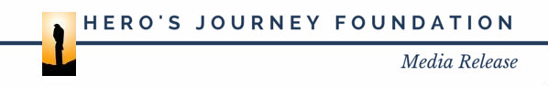

I, the undersigned, do hereby consent and agree that Hero’s Journey Foundation, its employees, or agents have the right to take photographs, videotape, or digital recordings of me during the program I attend, and to use these in any and all media, now or hereafter known. I further consent that my first name and identity may be revealed therein or by descriptive text or commentary.
I do hereby release to Hero’s Journey Foundation, its agents, and employees all rights to exhibit this work in print and electronic form publicly or privately and to market and sell copies. I waive any rights, claims, or interest I may have to control the use of my identity or likeness in whatever media used.
I understand that there will be no financial or other remuneration for recording me, either for initial or subsequent transmission or playback.
I represent that I am at least 18 years of age, have read and understand the foregoing statement, and am competent to execute this agreement.
Name:
Address:
Phone:
Signature:
Date:
Witness for the undersigned:
Witness contact:
Date:

